Welcome to Thornbury Kindergarten and welcome back to all our returning families!

Thornbury Kindergarten Inc. is a community-run kindergarten. This means that the Committee of Management (CoM) runs the kinder in close association with, and for the benefit of, staff and families.

The CoM is made up of volunteers and is responsible for hiring staff, the financial management of the kindergarten, policies, occupational health and safety, maintenance, quality assurance and organising social and fundraising events.

The Kindergarten cannot operate without a Committee of Management.

Join our Committee in 2023
Every year we are looking for enthusiastic and willing parents/carers to contribute some of their time and skills by joining the CoM. When you’re involved in the CoM, you’re not only making a valuable contribution to Thornbury Kindergarten you’re also participating in a unique and very rewarding experience.

There are a number of positions available in 2023 due to current members retiring at the 2022 AGM.

Current Committee members have briefly described (below) what their roles involve so families can determine which role might suit them.

Should you wish to nominate yourself, we (the current CoM) can assist with proposing and seconding your nomination form. Please contact Meagan, our Secretary, by email (secretary@thornburykinder.com) or phone (0402163261) should you have any questions.
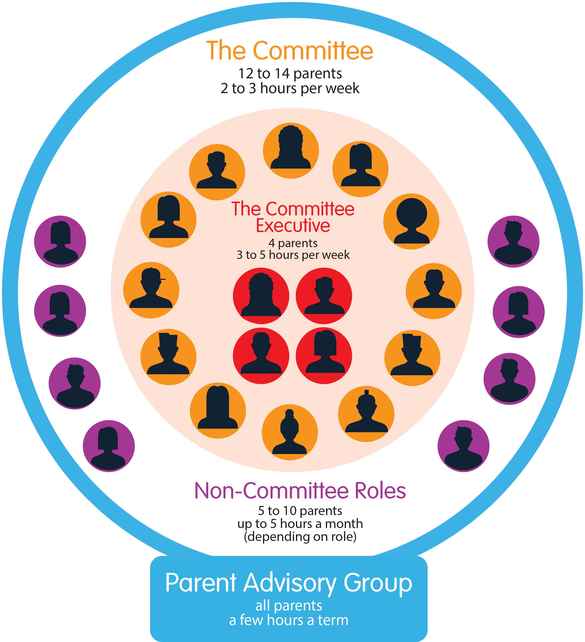
“It’s been very rewarding to be part of the Committee this year and helping make decisions on important issues facing the kindergarten. I don’t think I’d have such deep respect for the way the kinder is run if I wasn’t on the committee, and I’m sure that’s enhanced my child’s time there. She loves that ‘Mum goes to meetings at kinder’ and we feel really connected to the community.”

The Thornbury Kindergarten Parent Advisory Group
The Committee is part of the Parent Advisory Group, which every parent and carer becomes a part of as soon as their child joins the kinder.

There are many ways you can contribute to the Advisory Group without necessarily being on the Committee, including informal volunteering – perhaps reading to children in your group every now and then or going on excursions – and getting involved in roles that sit outside the Committee, such as Gardening Guru or Working Bee Coordinator.

Election of Committee of Management

The 2023 Committee of Management will be elected via nominations prior to, and at, the 2022 Annual General Meeting. If you would like to contribute further to your child’s kindergarten experience and get to know people in your local community, please consider nominating for a position on the Committee of Management. A description of the roles available follows.

Each year we welcome new members onto the Committee. Parents/Carers and extended family members e.g. grandparents who have children attending the kindergarten either for the first time in 2023 or who are already part of the kindergarten community are encouraged to nominate. It is important to retain several current members on the Committee to ensure continuity and build expertise for the sound operation of such an important service. Nominations will be taken prior to, and at, the AGM. We recommend that you lodge a nomination before the AGM by completing the nomination form below and emailing or mailing it to The Secretary, Thornbury Kindergarten, 8C Newcastle St, Thornbury 3071.

If you cannot attend the AGM, you can still nominate for a position prior to the AGM. Should you have any questions, or you would like a more detailed description of committee roles, please contact our Committee Secretary, Meagan Clark via email at secretary@thornburykinder.com or on 0402163261.

Thornbury Kindergarten Inc. Committee of Management roles 2023

Thornbury Kindergarten Committee of Management (CoM) will work in the following groups in 2023:

Executive Committee members – include the President, Vice President, Secretary and Treasurer. Executive Committee members are required to attend monthly CoM meetings, provide a report for each meeting and may be required to attend additional meetings as required throughout the year. They will also support and be supported by the General CoM roles, as listed in the bubbles below, when necessary.

General Committee members – attend the monthly CoM meetings and provide a monthly update/report for each meeting. They will also support and be supported by the Executive Committee roles, as listed in the bubbles below, when necessary.

Child Safety Support Officer is a role undertaken by a staff member. This role will not be required to attend monthly meetings. They prepare a report for each CoM meeting and liaise with the executive Committee Members and Director regularly.

Non-Committee Roles- these are roles that do not form part of the CoM but work closely with the CoM and Director throughout the year. These roles include Working Bee Coordinator, Garden Guru, Fundraising and IT Guru (see below for further details).
President
*Executive Committee
* Director
*Staff Liaison

Vice-President
*Policy & QA Rep
*OH&S Rep
*Child Safety Officer (staff role)
*Off-Site Programs Rep

Treasurer
*Enrolments Rep
*Fundraising & Merchandise Rep
*Grants Rep

Secretary
*Communications Rep
*General and Foyers Rep
*Coordinator Rep
*Sustainability

Role Descriptions
EXECUTIVE COMMITTEE ROLES
 | Role Description
President | The role of the President is interesting and varied. The President is required to chair the monthly meetings and ensure all decisions are carried out in a democratic manner. The role requires a good, strong working relationship with the kindergarten’s Director and Educational Leader.  It is also important to develop an understanding of all Committee roles and develop a relationship with the other Committee members so that responsibilities are clear and work is completed. The President does not necessarily need to work on every single piece of Committee business but should instead be in close and constant contact with members of the Executive, each of whom is responsible for a group of general Committee members.  The President is required to attend some staff meetings, sub-committee meetings, write monthly reports, meet weekly with the Director, contribute to the newsletter and be a point of contact for staff, families and committee members as required. They may also need to attend City of Darebin meetings from time to time.  The role also involves developing a strategic vision for the kinder. Preparing for changes in legislation and the impact of these on the kinder in the longer term, as well as making sure that new Committees have a guiding document to work from, is vital.  The President is, from the perspective of the regulator, the Approved Provider for the kindergarten. This means that it is the role of the President to ensure that all regulatory obligations are being met. An important aspect of the role is therefore maintaining (and in some cases creating) systems and processes to ensure this. The support of a strong committee and dedicated staff is essential to achieve this and in the success of the President more broadly.  The time spent in this role has varied from week-to-week, depending on what needs to be done. On average it requires 7-8 hours a week.  This position is vacant for 2023.
Vice-President | The Vice-President supports the President throughout the year, including chairing meetings when the President is not in attendance. They also assist with: Staff Liaison matters; reviewing roles and responsibilities of committee members; overseeing insurance matters for the kindergarten, conducting annual archiving for the kinder; preparing handover documentation for the incoming Committee, and acting as the main point of contact for the Child Safety Support Officer. They attend Darebin Committee network meetings over the year and are also responsible for coordinating Parent Information Nights at the Kindergarten. There are opportunities to help in various capacities, reviewing policies, annual strategic plan development, assisting at working bees, mini projects etc.  The time spent in this role varies from week to week, depending on what needs to be done. On average it requires 2-3 hours a week.  This position is vacant for 2023.
Secretary | The Secretary sends out the agenda for the monthly Committee meetings, takes the minutes and notes the actions. The Secretary acts as the main contact point between the kinder and non-financial organisations as well as being the main contact between the kindergarten and Consumer Affairs Victoria and the Australian Charities and Not-for-profits Commission who regulate Incorporated Associations. Can also attend Darebin Committee Network meetings as required and organise the AGM.  On average the role takes about 2- 3 hours per week with most communication between meetings taking place by email.  This position is vacant for 2023.
Treasurer | The Treasurer works closely with ASK Bookkeeping Services (ASK), the company who provides our Accounting and Fee Management Service. The treasurer is the main approver for electronic payments (and cheques if required) and authorises payments alongside another approver.  The Treasurer monitors income and expenditure monthly to make sure we are tracking to budget and prepares a short report to the committee each month. The following year budget and fees are set by the Treasurer and approved by the committee. The Treasurer also follows up outstanding fees if required and supports families with payment plans as required. There is some liaison with the auditors at the end of the financial year. The Treasurer also works with the Staff Liaison Representative around any pay matters and recruitment of new staff. Supporting the Fundraising, Enrolments and Grants Representatives as required throughout the year is also important in this role.  The role generally takes 3 hours each week, with peaks at certain times during the year.  This position has a nomination for 2023.

GENERAL COMMITTEE ROLES
 | Role Description
Staff Liaison Representative | The Staff Liaison Representative (SLR) is responsible for providing overall Human Resources and management support to the Director, with assistance from the President, Treasurer and ASK (accountant).  The SLR is the communication point between staff and their employer, the kinder Committee of Management.  The person fulfilling this role would benefit from human resource or people/line management experience but it is not a requirement. More importantly - staff well-being and the goal of supporting staff is the focus.  The Director manages general day-to-day staff issues – the SLR’s main role is to supervise the Director and support them in their human resources and operations management function, which includes overseeing human resources management of all staff.  Requirements of the role:  - Apply general understanding of the relevant Awards (CSA and VECTEA) and pay rates.  - Oversee human resources QA/compliance requirements, including employee files.  - Support the Director in management of staff, including recruitment, contracting and onboarding, bi-annual performance reviews, employee relations issues and incidental staff requirements such as overseeing sick leave and other leave requests, liaising with the OH&S Rep as required and assisting with rostering and timetabling.  - The above support requires oversight and maintenance of end to end HR policies, procedures and practices covering recruitment, induction, performance management and contracting.  - Coordinating annual staff survey, including engagement, analysing and sharing results and ensuring appropriate action planning.  The role involves around 4 hours per week and perhaps more at certain times such as during a recruitment process or bi-annual performance reviews.  Attendance at monthly staff meetings, which are usually held on the first Tuesday of the month from 4.30pm-6pm, is ideal in this role.  This position has a nomination for 2023.
Policy and Quality Assurance Representative | The policies component of this role is to ensure that kindergarten policies are up to date. The Policy Officer maintains the policy register in Dropbox, which is a comprehensive list of all policies with details about when they are due for review and who owns the policy.  At the time each policy requires reviewing the Policy Officer makes a copy of the policy to review, marks up (electronically) any alterations known in advance – for instance through the Early Learning Association of Australia (ELAA) website – and sends it to the relevant staff members or committee members who also have input into the review process. If required ELAA can be phoned for a discussion on policy matters as the kinder are paid members. The final stage of the policy adoption or approval process is discussion at a committee meeting followed by a two-week period of feedback for parents to have input before final approval.  Up to date copies of policies need to be maintained in the PolicyWorks Manual in the main foyer of the kinder for parents to have access to.  The Quality Assurance component of this role is responsible for coordinating the Quality Improvement Plan (QIP) updates and conducting the annual parent survey and committee survey.  This role takes on average a few hours per week.  This position is vacant for 2023.
Off-Site Programs Representative | The Off-Site Programs Representative supports the kindergarten staff in the resourcing and implementation of the Bush Kinder program and Out & About Off-Site Programs.  Responsibilities include:  - Liaising with staff and assisting where necessary e.g. Sourcing/restocking supplies and equipment  - Liaising with other users of the Bush Kinder and Out & About Sites (e.g. Park Rangers, Council)  - Attending monthly Thornbury Kinder Committee of Management meetings  - Maintaining a productive relationship with Darebin Parklands Committee.  - Ensure policies and handbooks are up to date with relevant information relating to the Off-Site Programs.  - Be a point of contact for parents and other people interested in the Off-Site Programs  The Off-Site Programs representative role is ideal for those that appreciate the benefits of outdoor learning programs. It is particularly suited to those with good communication and organisation skills.  This role takes on average 1-2 hours per week.  This position has a nomination for 2023.
OH&S Representative |  | The OH&S Representative consults with the staff and meets the employer obligations of providing the staff with a workplace free from health and safety risks.  Responsibilities include:  - implementation of the risk control plan  - liaising with the Director and Council  - undertaking site checks and evacuation drills  - ensuring the Emergency Management Plan is up to date as well as ensuring ongoing continuous improvement  - participate in quarterly OH&S meetings (usually within the staff meeting)  - responsible for monitoring workplace health and safety issues and investigating any workplace incidents or injuries  - if required, the role also helps facilitate return to work for injured employees  This role works closely with the Director and Staff Liaison Representative and must provide a monthly report to the CoM.  This role takes on average 1-2 hours per week.  This position is vacant for 2023.
Enrolments Representative |  | The Enrolments Representative is required to ensure that the Director and Treasurer are kept informed of any changes to enrolments during the year. Throughout the year you will also be communicating with the City of Darebin Centralised Waiting List staff when changes to enrolments occur and liaise with the Council to enrol new families into the kinder. Experience in Microsoft Word and basic Excel, together with good organisational skills would assist in managing this role.  The Enrolments Representative is responsible for liaising with EnrolNow to ensure the effective use of the software, including but not limited to arranging for emails to be sent by EnrolNow in relation to enrolments and ensuring all pertinent information is captured in the forms provided by EnrolNow.  The busiest period of the year is from September to December where you are required to organise and distribute Welcome Letters, oversee the allocation of children into their groups, organise and distribute Enrolment Packs and information to new kinder families in preparation for the following year.  This role takes on average 1-2 hours per week.  This position has a nomination for 2023.
General and Foyer Representative  - General Rep  - General Rep |  | There are 2 General and Foyer Rep positions available in 2023.  The general part of this role is really a ‘fill the gaps’ role – it involves any additional tasks that arise and do not fit under a specific Rep’s portfolio. It involves attending CoM meetings, assisting the CoM with ideas, relevant knowledge or helping make decisions. This role is partly to support and assist CoM colleagues in their roles. Examples of tasks include helping at kinder events, taking minutes when the Secretary is unavailable, etc.  Another part of this role is work with the Director and Administration Officer to update the noticeboards (usually at the start of the year) to ensure the latest licensing and legal items are displayed. General upkeep of the information in the foyer is also required, for example, staff and committee photo boards.  These positions are vacant for 2023.
Fundraising & Merchandising Coordinator |  | The Fundraising and Merchandising Role is responsible for organising several fundraising and community events throughout the year and for selling kinder merchandise.  Fundraising:  The primary goal of the Fundraising Role is to raise money for the kinder and have some fun. They are supported a team of fundraising volunteers within the kinder community as required.  This involves:  - Communications regarding upcoming events through the website, fliers, newsletter and emails to the kinder community.  - Attending committee meetings and reporting on fundraising/community events’ success and profit.  - Managing the funds; keeping clear records of expenditures and income and reporting this to the Treasurer.  - Overseeing and coordinating with the other fundraising non-committee volunteers  - Coordinating social events e.g. Trivia Night/Silent Auction, Kinder Disco, Bunnings BBQ, Start of Year and End of Year Picnics  - Coordinating kinder photos and the family photo fundraiser in October  - Preparing a brief article for the newsletter each term  Merchandising:  The merchandising component of this role involves filling merchandise orders and supplying the items purchased to families. Order forms need to be available in both foyers. Records need to be kept, money needs to be banked and merchandise stock-takes conducted twice per year. Merchandise should be re-ordered when necessary. Merchandise should be made available for purchase at events such as the Welcome Kinder Picnic and the AGM.  This position has a nomination for 2023
Communications Representative |  | The Communications Representative works to keep the kinder community informed via several channels (emails, posters, newsletters, website and WhatsApp). This is a great role for people keen to collaborate, communicate, and maximise feedback from the community. It includes:  - Compiling the Newsletter each Term  - Creating posters for events and fundraising activities  - Managing the community’s private Facebook group  - Maintaining the kinder website  - Collating the Year Calendar  No specific marketing or web design skills are necessary – the website is hosted on Wix and the posters/newsletter are Canva templates – both programs are user-friendly and simple to maintain. Inclusivity and accessibility are incredibly important within the culture of the kinder and should be imbedded in all communications.  This role takes on average 2 hours per week.  This position has a nomination for 2023.

Grants Representative | This role involves identifying, applying for and acquitting grants that the kindergarten is eligible to apply for. Relevant grant sources need to be identified and there are several websites to be monitored for funding opportunities. This role requires liaising with kindergarten staff and the Committee of Management in order to identify funding requirements.  This position is vacant for 2023.
Sustainability Representative | This is a new position in 2023.  In 2015, the United Nations agreed to the below 17 Sustainable Development Goals (SDGs) as a call to action to ensure a better planet and future for all. This role will support Thornbury Kindergarten in implementing the SDGs, with a particular focus on our environmental impact goals 7, 11, 13 14 and 15.  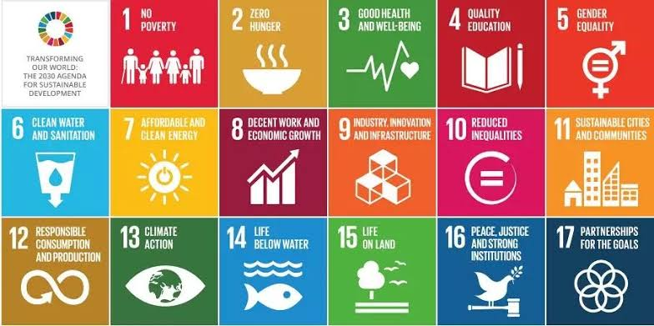  This position has a nomination in 2023.
NON-COMMITTEE ROLES
General Fundraising | The function of this role is to assist the Committee Fundraising Coordinator with the running of the kinder events. This includes things such as:  - Liaising with venues, council, businesses and various governing bodies if necessary  - Canvassing local business for donations  - Arranging a team of volunteers to assist  - Assisting with setting up and managing the Online Auction for the Trivia Night  - Setting up and managing ticketing and volunteers through different online systems  - Setting up and attending events.  This position is vacant for 2023.
Gardening Guru | The Gardening Guru will assist with the upkeep of the garden beds around the kindergarten and work in consultation with the Director, Volunteer Co-ordinator and Working Bee Co-ordinator.  This position is vacant for 2023.
In House Fundraising | This role requires organising fundraising projects within the kinder such as printed tea towels, plates, hot cross bun and cherry drives. This person will work closely with the Committee Fundraising Coordinator and other fundraising members throughout the year.  This position is vacant for 2023.
Working Bee Coordinator | The Working Bee Coordinator is responsible for organising the two working bees throughout the year. This person will work closely with the Volunteer Coordinator, Director, Treasurer and President to organise these days.  This position is vacant for 2023.
Child Safety Support Officer (Staff Member)  This position has been undertaken by a staff member since 2018. This position reports back to the Kindergarten Director and the Vice-President and is not required to attend monthly meetings. The Child Safety Support Officer meets with the members of the Executive Committee and Director regularly and provides a report to the CoM for each monthly meeting. | The Child Safety Support Officer (CSSO) will work to further embed the Victorian Child Safe standards into the kindergarten’s everyday practice and maintain a child safe environment. The CSSO will act as a Child Safety Champion, promoting child safety and will:  - Be a point of contact for both staff and children.  - Take action when any child protection incidents are reported to them, including providing support to affected members of the kinder community.  - Be responsible for reviewing a kindergarten’s processes and procedures in relation to child safety.  The Child Safety Support Officer will:  - Provide social media updates/information regularly.  - Provide monthly reports to committee via director and facilitate child safety conversations in monthly staff meetings.  - Contribute Child Safety content to the newsletter each Term.  - Promote awareness throughout the year, e.g. Child Protection Week.  - Present to the CoM in Term 1.  This position has a nomination for 2023.

Working With Children Check & Police Check
All Committee members and those undertaking Non-Committee roles listed above are required to hold a current Working With Children Check or VIT registration. Executive Committee members are additionally required to have a Police Check.

